MPCA LAB

WEEK – 7

Name : Laxmikant Bhujang Gurav

SRN : PES1UG20CS658

Roll no. : 55

Date : 15-03-2022

**Program 1 :** Execute the following programs on ARMSIM – plug–ins. Display hexadecimal digits [0–9, A–F] on the 8 segment display.

**Code :**

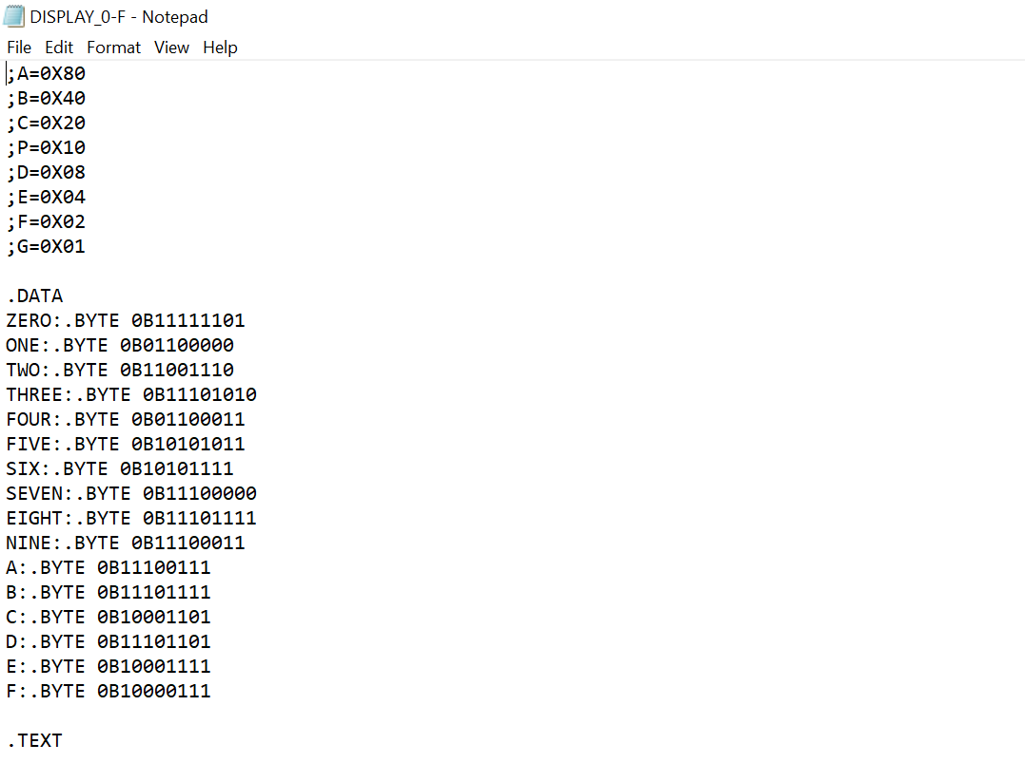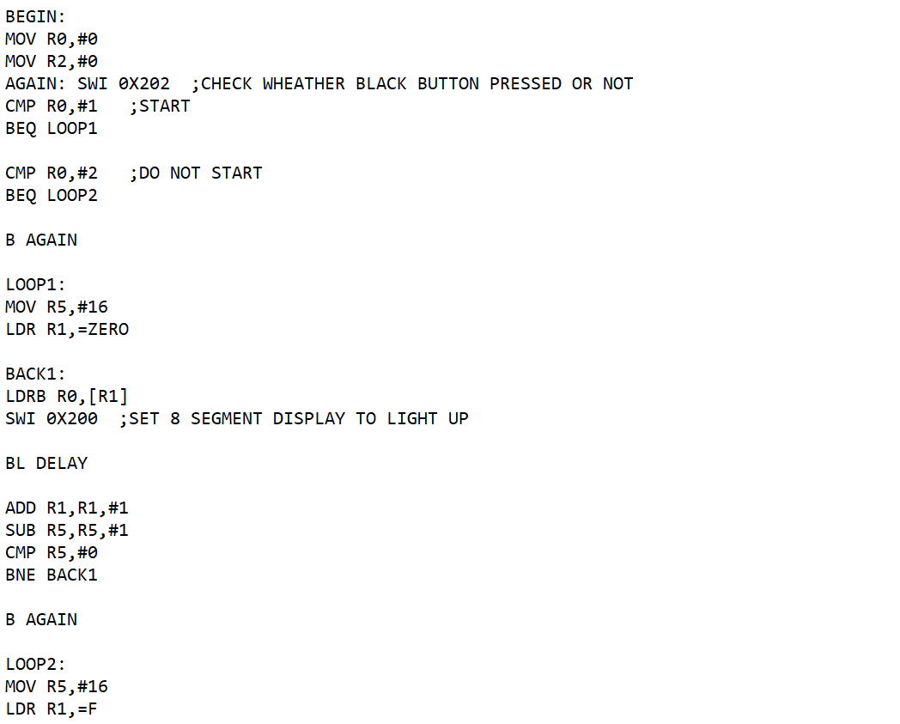

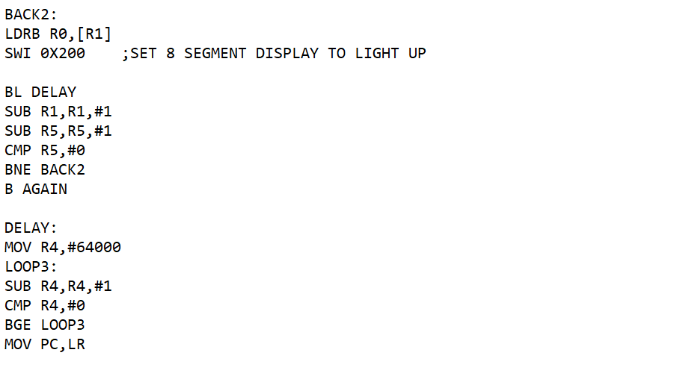

**Output :**

**Screenshot 1:**

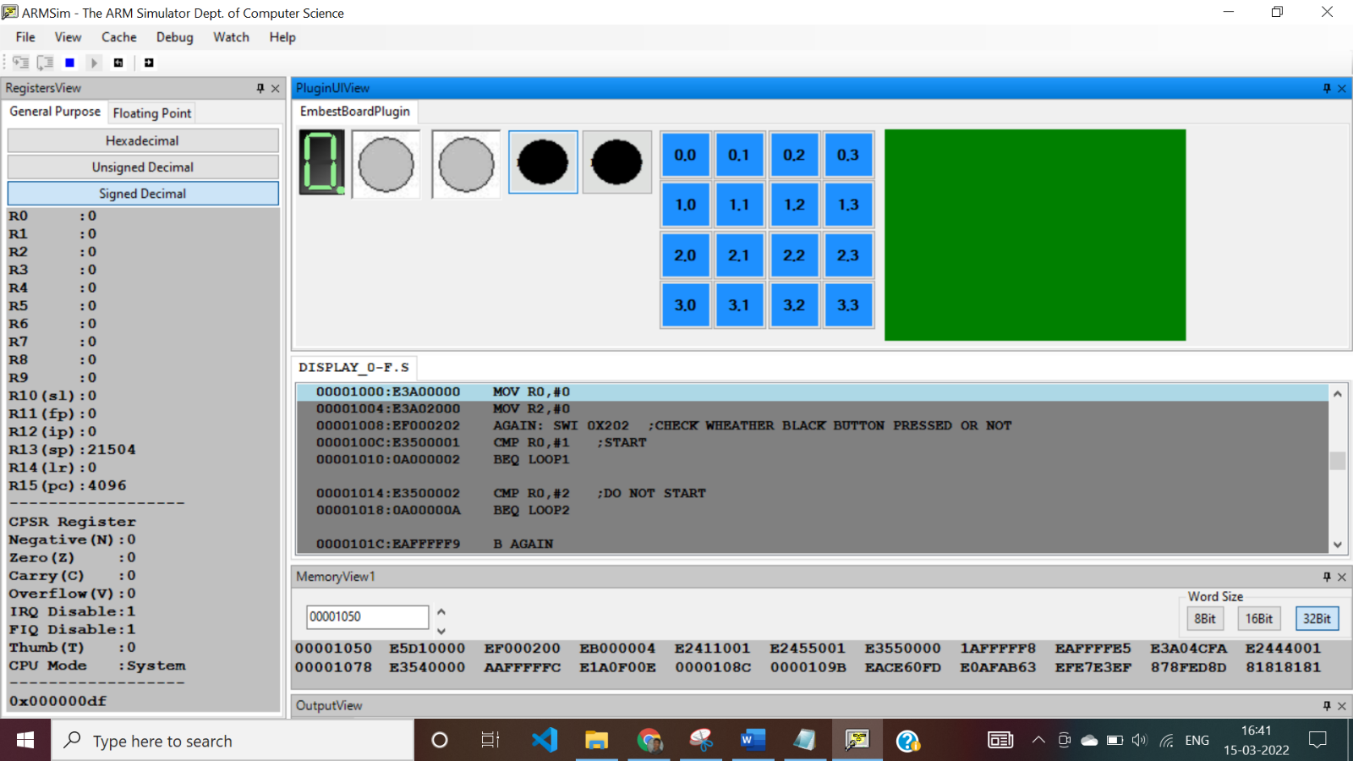

**Screenshot 2:**

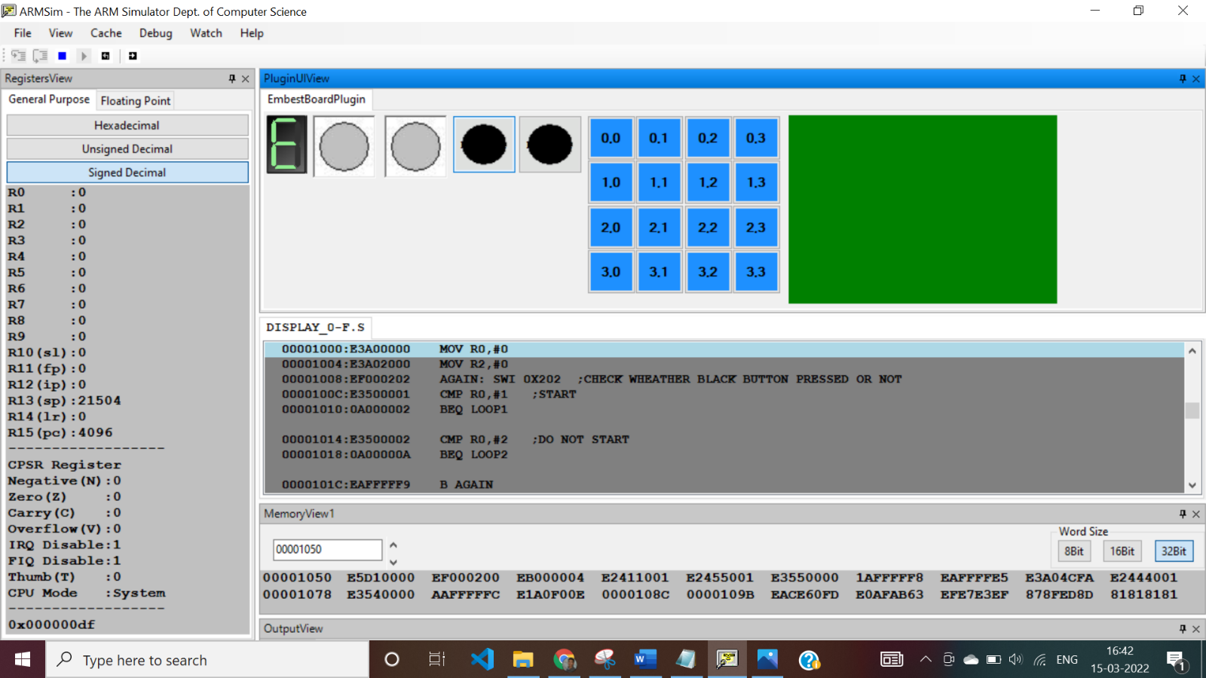

**Screenshot 3:**

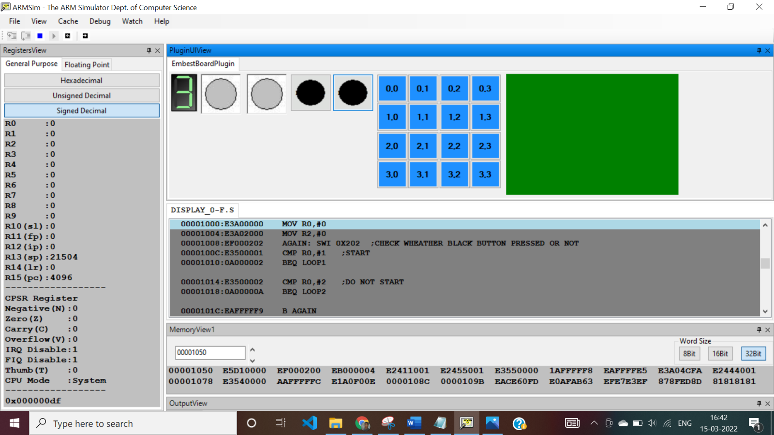

**PROGRAM 2 :**

Execute the following programs on ARMSIM – plug–ins.

Move a string from LEFT to RIGHT on the LCD display panel.

**Code :**

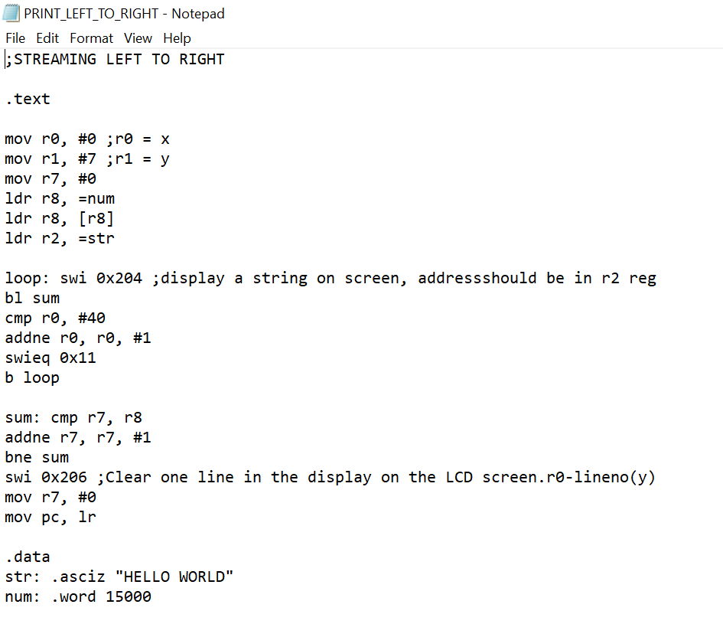

**Output :**

